**Observable trend 1:**

Charter schools perform better than District schools in all parameters

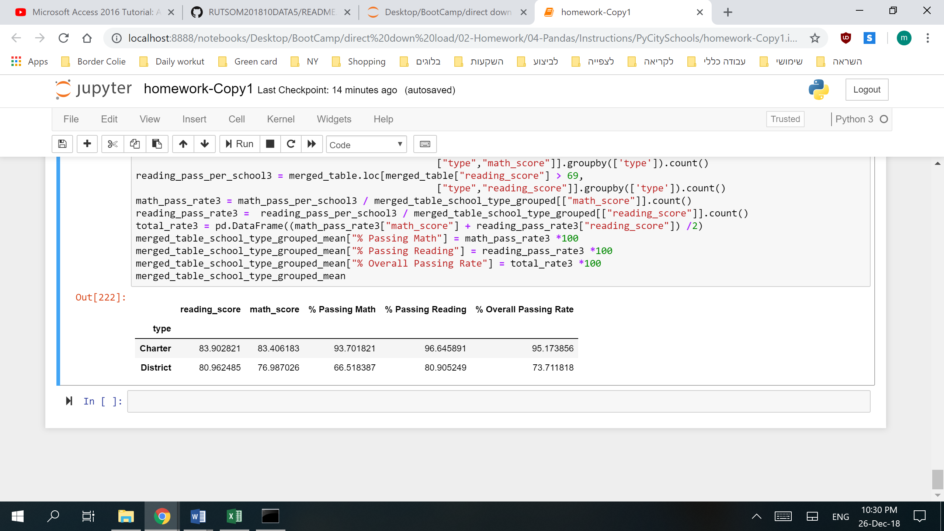

**Observable trend 2:**

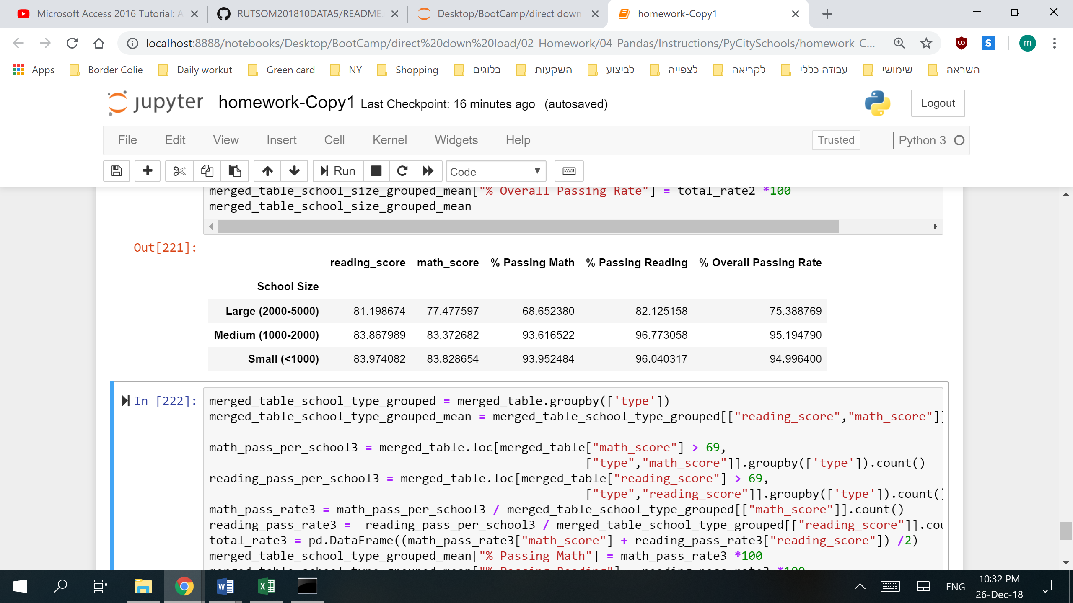

Large schools (2000-5000 students) perform slightly worse than medium and small schools.

Medium and small schools perform almost identically